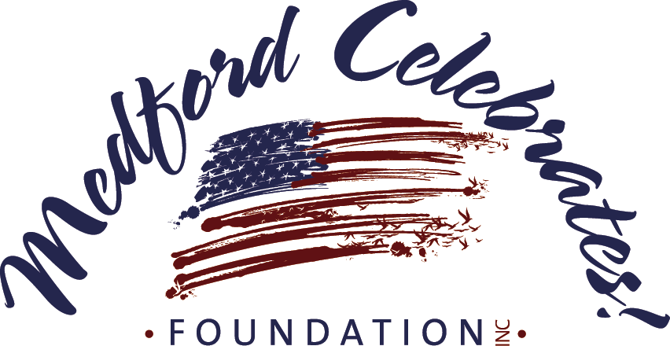
April 2024
To: Invited Vendors
From: Medford Celebrates Foundation, Inc.
Re: Food Vending Spaces Available
Event: Independence Day Celebration, Freedom Park, Medford, NJ
Date: WEDNESDAY, JULY 3rd, 2024 from 6:00 pm - 10:00 pm (Raindate: SATURDAY, July 6th)

The Medford Celebrates Foundation, Inc. (MCF) is excited to be offering food, non-profit and other vendors an opportunity to participate in Medford Township’s Independence Day Celebration and fireworks display. This year’s event will be held from 6:00 pm - 10:00 pm on WEDNESDAY, JULY 3rd. (The raindate is Saturday, July 6th)

This is one of Medford’s largest events, and draws over 20,000 people to the Medford area. MCF is the fundraiser and planner helping Medford Township stage the evening -long event. Event attractions at Freedom Park (beyond the large fireworks display) include entertainment for children, live music, food and much, much more. We want to enhance the attendees’ experience and accommodate the crowds by providing a diversity of food, non-alcoholic drink and other vendor specialties at strategically placed locations in Freedom Park – and you are invited to participate!

TO PARTICIPATE: Vendors must submit a complete application packet. MCF reviews and accepts or rejects applications and assigns spaces to vendors in Freedom Park in its sole discretion. We generally review and make decisions about applications on a first-come first serve basis. Space is limited. Application packets must include the following:
1. Completed Application Form (attached);
2. Certificate of Insurance in the minimum amount of $1million general liability insurance coverage
with Medford Township and Medford Celebrates Foundation, Inc. as additional insured certificate
holders;
3. Current County Health Department Certificate; and
4. Food Handlers permit issued by Medford Twp., call the Clerk’s Office (609) 654-2608 x334

IMPORTANT: If your vending operation includes the use of any open flame or flame-producing device, a Township of Medford Fire Permit will also be required. Upon approval of your application by MCF, a Type 1 permit request must be filed and remitted directly to the Township of Medford Fire Division, with a copy sent to MCF. This application is available at www.medfordfire.org/forms/permit.pdf. A separate fee of $42 for the Fire Permit is required for each vending spot.

VENDOR PERMIT FEE: Make checks payable to Medford Celebrates Foundation, Inc.
Product Vendor permit…………………………………………..…$500
Product Vendor permit for Medford resident or business ……..…$300
Activity Vendor (Face Painter/Spin Art, etc)……………. ..$150

For the event, vendors must be self-contained, and bring their own tables, chairs, tents and generators if needed. GENERATORS CANNOT EXCEED 60 DECIBLES. NO electricity or water will be provided.

After your application is received and approved, you will be notified by mail about your opportunity to participate. This may include limiting the items you can sell and setting a specific location at Freedom Park at which you may sell items. Any attempt to sell items that are not approved in advance or to locate at a place other that the one that is assigned to you may result in your ejection from the event without refunding your fee. For more information, call during business hours to (609) 654-2608 x330 or e-mail info@medfordnjcelebrates.org.

2024 INDEPENDENCE DAY CELEBRATION and FIREWORKS DISPLAY
WEDNESDAY, JULY 3rd | 6:00pm - 10:00pm | Freedom Park, Medford, NJ

REPLY REQUIRED by JUNE 10, 2024 | SPACE LIMITED | APPLICATIONS REVIEWED FIRST COME, FIRST SERVE

2024 Vendor Application

Vendor Business Name:

D/B/A:

Contact Person:

Street Address:

City _____________________________________________________State _______ Zip ______________

Business #: (_____) _____________ Cell #: (_____) _____________ Other #: (_____) ______________

Email: ____________________________________________ Fax #: (_____) ______________________
Description of proposed menu or offerings: (**List all items that you propose to sell. No additions or changes to this menu/offerings will be permitted) _________________________________________________________________________________________________________________________________________________________________________________________________________________________________________________________________________________
Description of set-up: (trailer, tents & tables, generator, fryers, etc.) _________________________________________________________________________________________________________________________________________________________________________________________________________________________________________________________________________________
Enclosures:
____ APPLICATION
____ FEE
____ CERTIFICATE OF INSURANCE
____ HEALTH DEPT CERTIFICATE
____ MEDFORD FOOD HANDLERS PERMIT
____ MEDFORD FIRE PERMIT (if applicable)

To apply for a permit, return this form, event fee and other documentation by June 10, 2024 to:
Vendor Coordinator
c/o Medford Celebrates Foundation, Inc.
P.O. Box 933, Medford, NJ 08055-0933

By submitting an application, you agree to the terms and conditions set forth in the accompanying letter.

For additional information or help with your application, contact (609) 654-2608 x330 or info@medfordNJcelebrates.org

